transclust: A R package for detecting, visualizing and analyzing clusters of transmission
Abhirath Anand
Summary
transclust is a versatile R package that allows users to combine genomic and epidemiological data to detect, visualize and analyze transmission clusters. It aims to be a tool to help users to study their data with various methods to inform their understanding of the underlying mechanism that best describes the data. The results generated by this package will help users better understand transmission dynamics and potentially inform the design of interventions to prevent further transmission and spread of the pathogen.
Statement of Need
The use of whole genome sequencing to design interventions for disease prevention is becoming increasingly common in healthcare settings. One major obstacle is using this data to decide a method to designate specific events as having arisen because of transmission. The most common approach to do this has been to use a single-nucleotide variant (SNV) threshold, although recent studies have tried to come up with approaches that are less dependent on a choice of threshold. This motivated the idea of a package that would allow users to analyze epidemiological data with various approaches and decide what works best for their particular use case.
Description
Data Collection and Preparation
The data format that this package uses is described in detail in the design documents provided in the package repository in the datasets.md file. Specifically, it uses a combination of genomic data (in the format of FASTA files) and patient surveillance data (in the format of an Rdata file containing particular types of vectors and matrices). The exact specifications are omitted here for brevity.
For the preliminary analysis described in this paper, a dataset from a study monitoring a one-year intervention in a hospital to prevent colonization and infection with Klebsiella pneumoniae harboring the bla_{KPC} carbapenamase (KPC-Kp) was used. A detailed description of the study used to obtain this data is described in a previous paper.¹ This is then preprocessed using the pipeline described in Hawken et al. (2022).² Summarized briefly: after filtering and trimming low-quality reads, variants were identified by mapping reads to sequence type (ST)-specific reference genomes.
A specific subset of this dataset is used for evaluating the package, and is provided as an example dataset along with the package. In particular, genome sequences and epidemiological data for sequence type 258 of KPC-Kp was chosen. This was done because ST258 is the most prevalent subtype of KPC-Kp in the USA³, and thus has a wide range of patient data associated with it, allowing the clustering algorithms to derive more powerful insights while also serving as a reasonable benchmark for running times.
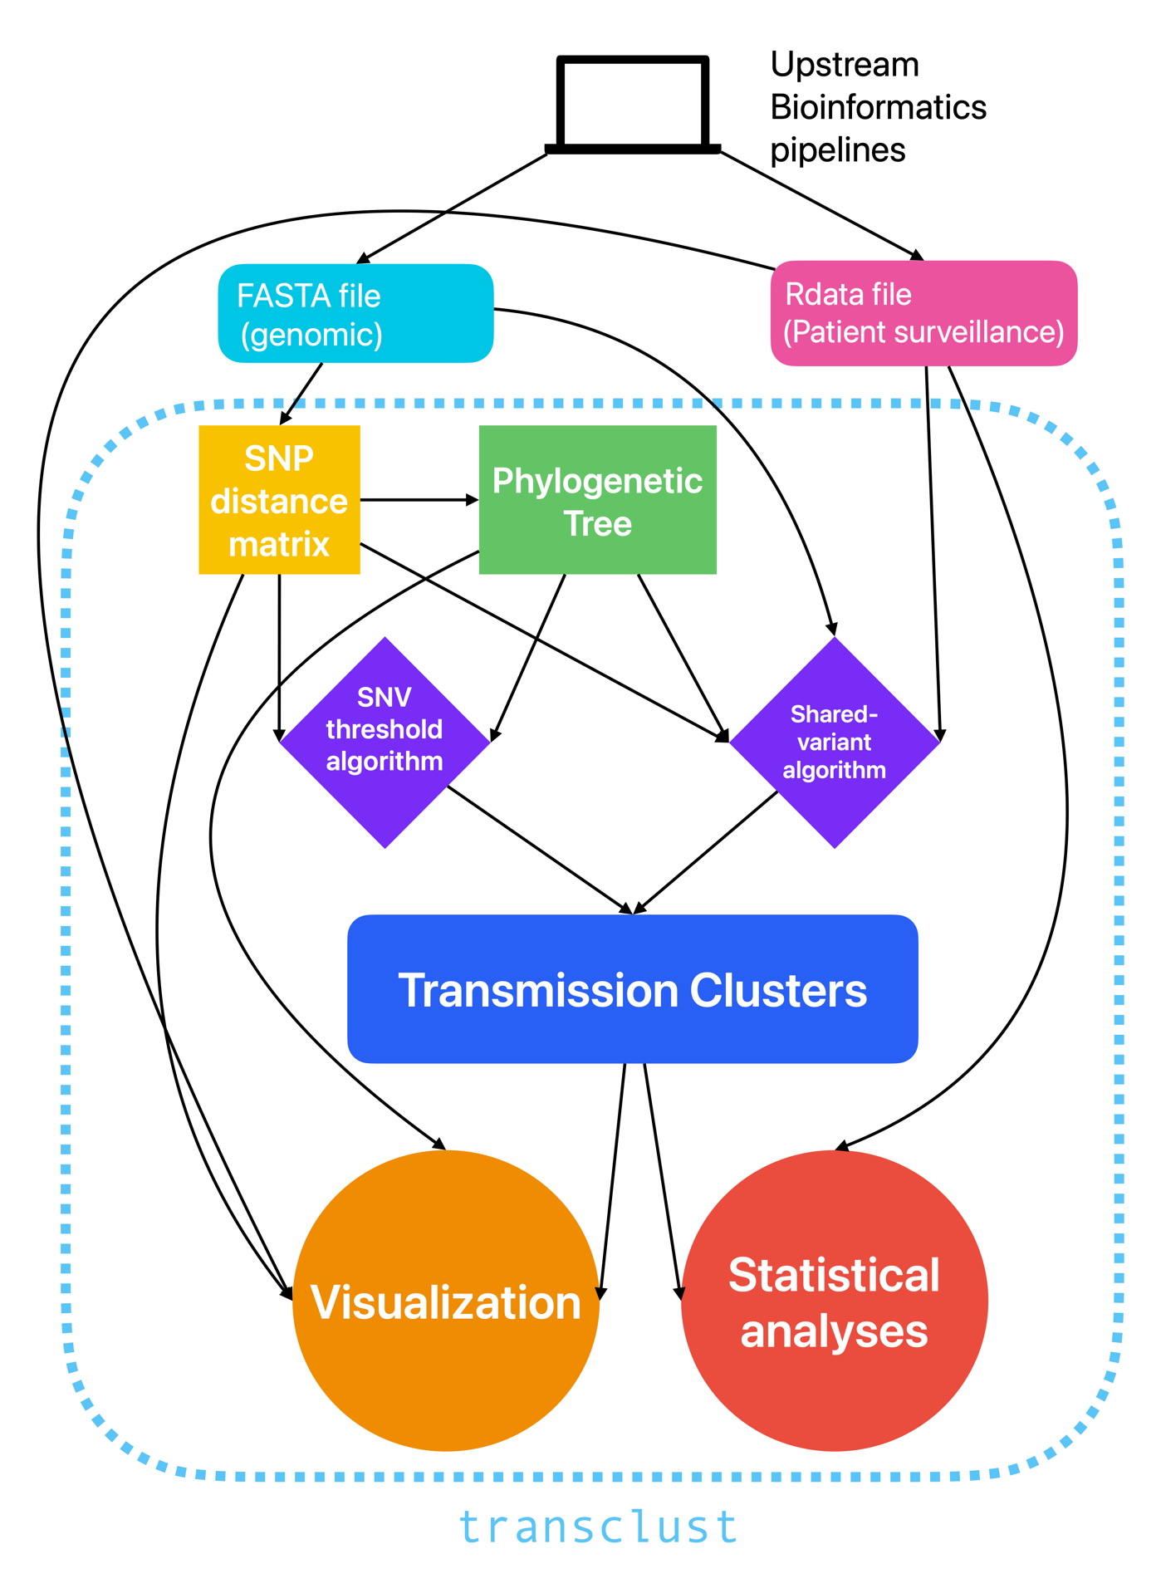
Figure 1 Overview of the general workflow using transclust.
Overall workflow
An overview of working with this package is described in a vignette. This can be accessed either by looking at the package documentation or by running vignette(transclust) in the R interpreter after loading the package. A graphical diagram depicting the workflow that the vignette walks through is shown in Fig 1. This describes the data and the flow of the stages involved in working with the raw data and using the functions provided by transclust. transclust provides utility functions for SNP distance matrix calculation and phylogenetic tree generation, both crucial steps in converting the raw data into intermediate forms that transclust’s algorithms can utilize for deriving information about transmission clusters.
Clustering methods
One pre-existing method for inferring transmission within a facility is to use a single-nucleotide variant (SNV) threshold^{4–6}. Isolates with distances below this threshold are considered to have been a result of transmission, and those above it are seen as improbable for a transmission event. The problem with this is that the choice of SNV threshold becomes hugely important in deciding the dynamics of transmission that we observe. More restrictive choices for threshold fail to account for so-called “hypermutator” strains that might emerge from long-term colonization of a patient and subsequent transmission.
In the last few years, approaches have increasingly centered on eliminating this reliance on the choice of threshold. One such approach uses a shared-variant based algorithm, combining genomic and epidemiological data to infer transmission in healthcare settings in a threshold-free manner². Briefly, the shared-variant based algorithm uses a maximum parsimony tree and decides transmission clusters in the tree by evaluating monophyletic clades using a set of specific criteria:
- all members of the cluster share at least one variant not present in non-cluster members.
- multiple admission positive patients who could have started the cluster are allowed only if none uniquely shared variants with cluster members.
- The cluster does not contain a valid cluster within it.
transclust implements both these methods, allowing the user to compare and choose the method that might provide better results for their use case. The SNV threshold algorithm is implemented in pure R. However, the shared variant algorithm function, in addition to using ape⁷ and phangorn^{8,9}, both phylogenetics packages in R, also makes use of helper functions written in Rcpp^{10–13}. These prove to be phenomenal for improving performance, resulting in a more than 10x improvement over a pure R implementation when benchmarked.
Both methods return named vectors that label each of the isolates with a cluster ID.
Visualization
The package contains functions for visualizing the results of the clustering in different ways. Most of these build on functions provided by ggplot2¹⁴, which is a popular and highly extensible R plotting library. One of the easiest ways for us to visualize such transmission clusters is to plot them on a phylogenetic tree by coloring each of the nodes based on what cluster it belongs to. This can be done with the help of the plot_clusters_phylo function:
plot_clusters_phylo(clusters, phylo_tree)
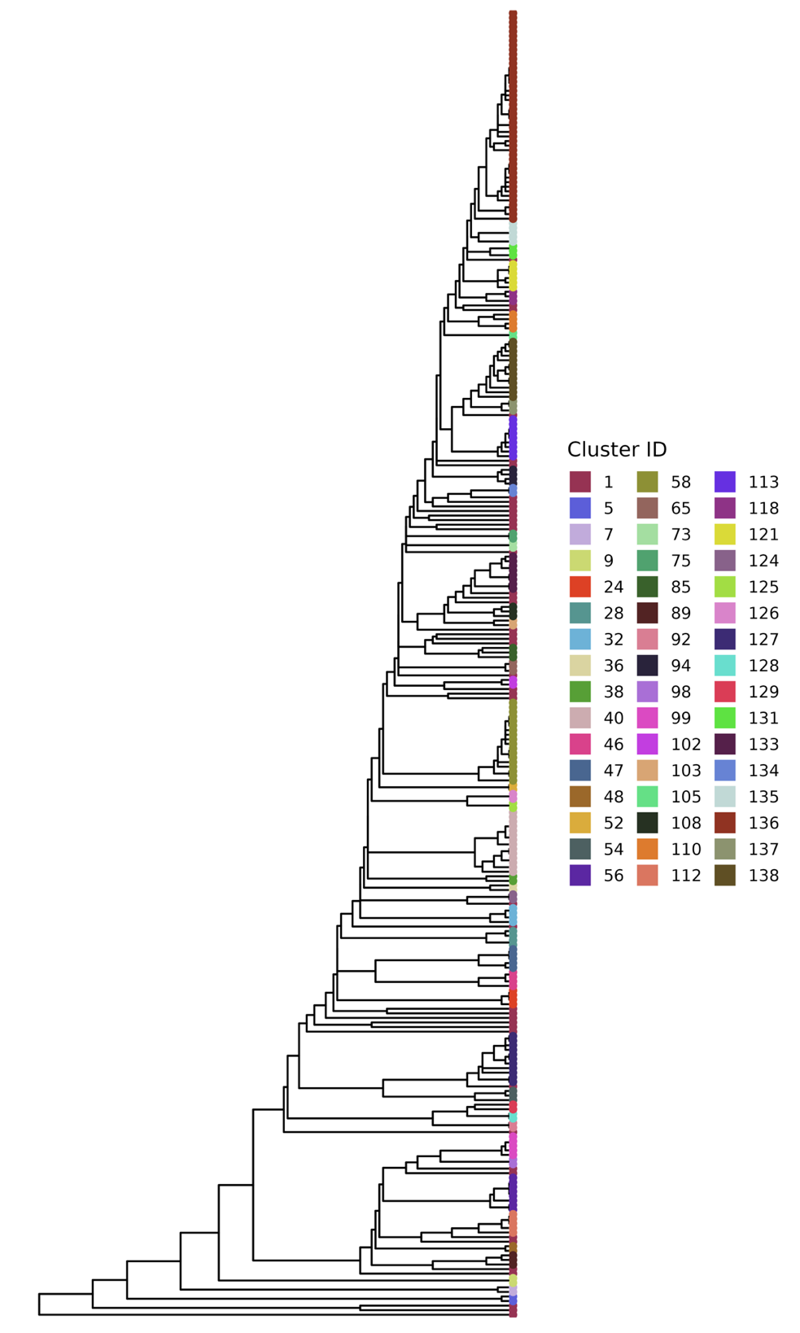
Figure 2 Phylogenetic tree labelled with transmission clusters.
Fig 2 was generated in this manner. This function uses ggtree^{15–17}, a plotting library in R that extends the grammar of graphics that ggplot2 provides to visualize and annotate phylogenetic trees along with other data. The function thus returns a plot object that can further be customized by the user using ggplot2 for their specific visualizing needs.
Since transclust provides multiple methods to identify transmission clusters, it also has a function that compares clusters generated by two different methods by generating a heatmap that highlights the proportion of isolates shared between clusters generated by different methods. This allows us to see if the two methods we are using are in fact identifying different sets of clusters. This function uses ggalign¹⁸ under the hood, which helps extend ggplot2 further to allow for the specification of more customizable and complex layouts with ease. This means that we get a plot object from compare_clusters that can be composed with ggplot2 for further customization. The function is called as below:
compare_clusters(clusters1, clusters2)
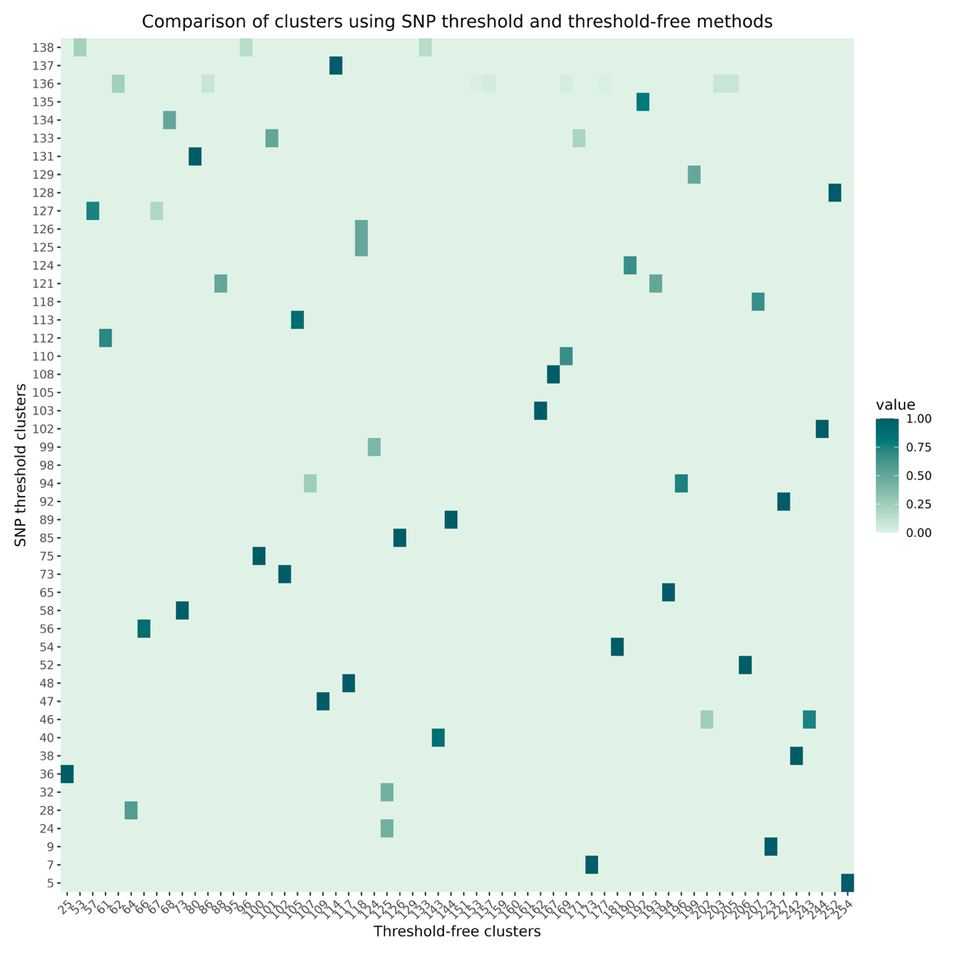
Figure 3 Comparing clusters generated by the SNV threshold and shared-variant approaches by plotting proportion of isolates that are common between clusters.
The output of this function is shown in Fig 3. We can clearly see that the heatmap is mostly sparse. This tells us that the SNV threshold method and the shared variant algorithm yield quite distinctive clusters with very different sets of isolates in each of the clusters. Analyzing this further will potentially reveal important information about the nature of transmission dynamics in the facility.
More visualization functions, specifically to visualize patient trace data (surveillance information about where the patient was in the facility and their infection status at the time, allowing us to identify transmission events on a temporal plot) are in development.
Statistical Analysis
transclust also provides some functions for statistical analysis of the clustering results. One of the functions is intra_cluster_genetic_var_analysis, which calculates the genetic variation within each cluster. This gives us the total number of variable sites and the proportions of each of the six types of base substitutions present in each cluster and in the population. After calculating this, we can plot this as a stacked bar plot using ggplot2 after some data cleanup. This is shown in the figure below.
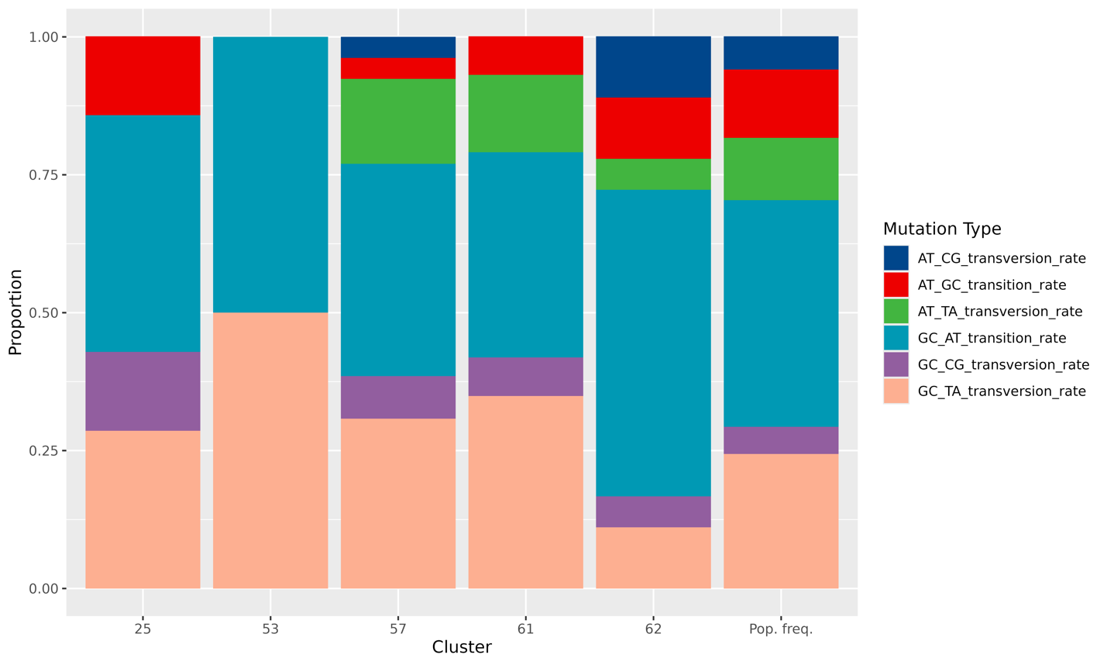
Figure 4 Mutational signatures of five randomly selected clusters along with that of the population frequency.
We can clearly see that very specific mutational signatures emerge in each of the clusters when compared to each other and to the population. This can potentially be used when looking at whole genome sequencing data during an ongoing epidemic – the proportion of these mutation types may help us better understand how the patient might have acquired the infection, thus not only preventing further spread but also helping us better inform clinical interventions.
More statistical analysis functions to supplement the workflow, including permutation tests to check for statistical significance of the transmission events identified are currently in development.
Limitations and future directions
One potential limitation of this package is that the algorithms described here work best for delineating transmission clusters in relatively closely related populations which at the same time are not too clonal – this means that broader application to a wide variety of datasets and to different pathogens will have to be informed by the genomic data available and the exact circumstances of the transmission. Another limitation is that surveillance data of the kind used in this paper is typically only limited to active surveillance studies targeting specific hospital units, as opposed to more general cases of spread.
Future iterations of the package will focus on polishing the API for this functionality, as well as on introducing more functionality for better visualization, more rigorous statistical analysis for evaluating the statistical significance of the clusters and potentially more algorithms for deciding transmission clusters. The package will also expand the set of vignettes to reflect a broader range of use cases for which it can be utilized, while also allowing users to test it on a wider set of pathogens that might yield important information about the performance of these algorithms for different reasons.
Availability and reproducibility
The data used for the analysis in this paper is provided as an example dataset with the package in the inst/extdata folder. The package as well as all associated documentation, tests and example workflows can be found at https://github.com/theabhirath/transclust.
All analyses shown in this paper have been performed with R 4.4.3 on an M1 MacBook Air, but the package has been tested extensively on CI for Windows, Linux and macOS on R versions >4.4.
Acknowledgments
I would like to thank Dr. Evan Snitkin for giving me the opportunity to work with him and to use data generated by his lab for the purpose of this project. I would also like to thank Kyle Gontjes and Aryan Singh, who are part of the Snitkin lab, for helping with code implementation, specifically viz. visualization of phylogenetic trees. I’d like to thank Bretton Badenoch for his useful contribution to the package, and for being a part of the code review and design ideation process, as well as Geordan Bolden and Natalie Oliven for initial comments on the code structure and ideation. And I’d like to thank Dr. Cristina Mitrea for code design inputs.

References
1. Hayden, M. K. et al. Prevention of Colonization and Infection by Klebsiella pneumoniae Carbapenemase-Producing Enterobacteriaceae in Long-term Acute-Care Hospitals. Clin. Infect. Dis. 60, 1153–1161 (2015).
2. Hawken, S. E. et al. Threshold-free genomic cluster detection to track transmission pathways in health-care settings: a genomic epidemiology analysis. Lancet Microbe 3, e652–e662 (2022).
3. Argimón, S. et al. Rapid Genomic Characterization and Global Surveillance of Klebsiella Using Pathogenwatch. Clin. Infect. Dis. 73, S325–S335 (2021).
4. Coll, F. et al. Definition of a genetic relatedness cutoff to exclude recent transmission of meticillin-resistant Staphylococcus aureus: a genomic epidemiology analysis. Lancet Microbe 1, e328–e335 (2020).
5. Sherry, N. L. et al. Pilot study of a combined genomic and epidemiologic surveillance program for hospital-acquired multidrug-resistant pathogens across multiple hospital networks in Australia. Infect. Control Hosp. Epidemiol. 42, 573–581 (2021).
6. Gouliouris, T. et al. Quantifying acquisition and transmission of Enterococcus faecium using genomic surveillance. Nat. Microbiol. 6, 103–111 (2020).
7. Paradis, E. & Schliep, K. ape 5.0: an environment for modern phylogenetics and evolutionary analyses in R. Bioinformatics 35, 526–528 (2019).
8. Schliep, K., Potts, A. J., Morrison, D. A. & Grimm, G. W. Intertwining phylogenetic trees and networks. Methods Ecol. Evol. 8, 1212–1220 (2017).
9. Schliep, K. P. phangorn: phylogenetic analysis in R. Bioinformatics 27, 592–593 (2011).
10. Eddelbuettel, D. & Balamuta, J. J. Extending R with C++: A Brief Introduction to Rcpp. Am. Stat. 72, 28–36 (2018).
11. Eddelbuettel, D. & François, R. Rcpp : Seamless R and C++ Integration. J. Stat. Softw. 40, (2011).
12. Eddelbuettel, D. et al. Rcpp: Seamless R and C++ Integration. 1.0.14 https://doi.org/10.32614/CRAN.package.Rcpp (2008).
13. Eddelbuettel, D. Seamless R and C++ Integration with Rcpp. (Springer New York, New York, NY, 2013). doi:10.1007/978-1-4614-6868-4.
14. Wickham, H. Ggplot2: Elegant Graphics for Data Analysis. (Springer international publishing, Cham, 2016).
15. Yu, G., Smith, D. K., Zhu, H., Guan, Y. & Lam, T. T. ggtree : an r package for visualization and annotation of phylogenetic trees with their covariates and other associated data. Methods Ecol. Evol. 8, 28–36 (2017).
16. Xu, S. et al. Ggtree : A serialized data object for visualization of a phylogenetic tree and annotation data. iMeta 1, e56 (2022).
17. Yu, G. Data Integration, Manipulation and Visualization of Phylogenetic Trees. (Chapman and Hall/CRC, Boca Raton, 2022). doi:10.1201/9781003279242.
18. Peng, Y. & Wang, S. Ggalign: A ‘ggplot2’ Extension for Consistent Axis Alignment. (2025).

